Name: - SHUBHAM DAS Date: - 20/09/2026
S.A.P I. D: - 590033500 Subject: - Programming In C

Experiment# 1: -
Purpose of the experiment: - To set up a Linux environment using Kali Linux VM in Oracle VirtualBox and demonstrate some basic Linux commands used for programming.

- Linux Programming Environment
We can write and run C language programmes using either an online Linux terminal or a Linux system installed on our computer.
- Online Method
For online practice and demonstration, CoCalc.ai is advised. It gives us a Linux terminal in a browser, so, we can write, compile, and run C programme without installing Linux e.g.: - nano file. c, cc file. c and./a. out
- Offline Method
1# Dual Boot: - Windows and Linux are both installed, and we choose one when the computer starts.
2# Single Boot: - Only Linux is installed on the computer.
3# Bootable USB: - Linux can be started from a pen drive without changing the main operating system.
4# Virtual Machine: - Linux will run inside the current operating system using virtualization software.
- Virtual Machine Manager (Hypervisor)
A hypervisor is software that helps us run a virtual machine. Type – 1 hypervisor runs directly on the hardware, while Type – 2 hypervisor runs inside an existing operating system. In this experiment, we shall use Oracle VirtualBox, which is a Type – 2 hypervisor, to run Kali Linux VM.
Installation of Oracle VirtualBox and Kali Linux VM: -
- Downloading Oracle VirtualBox on your system
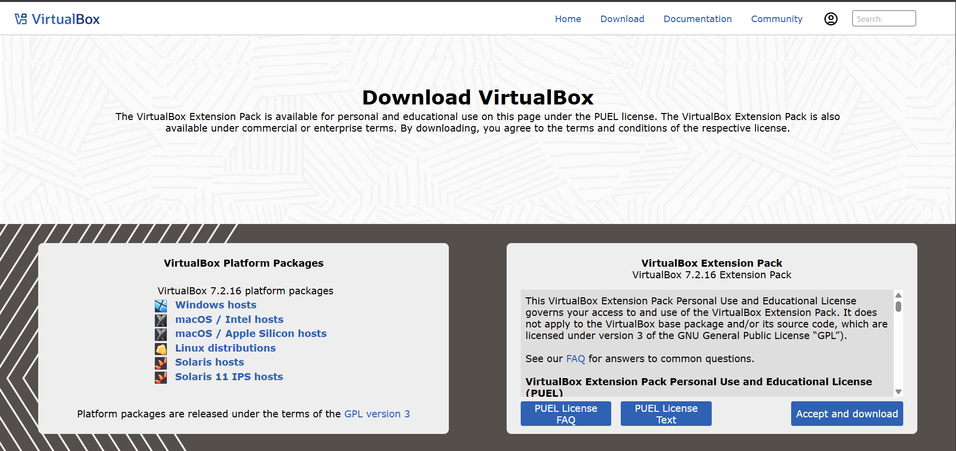
- Downloading the pre-built Kali Linux VM for Oracle VirtualBox
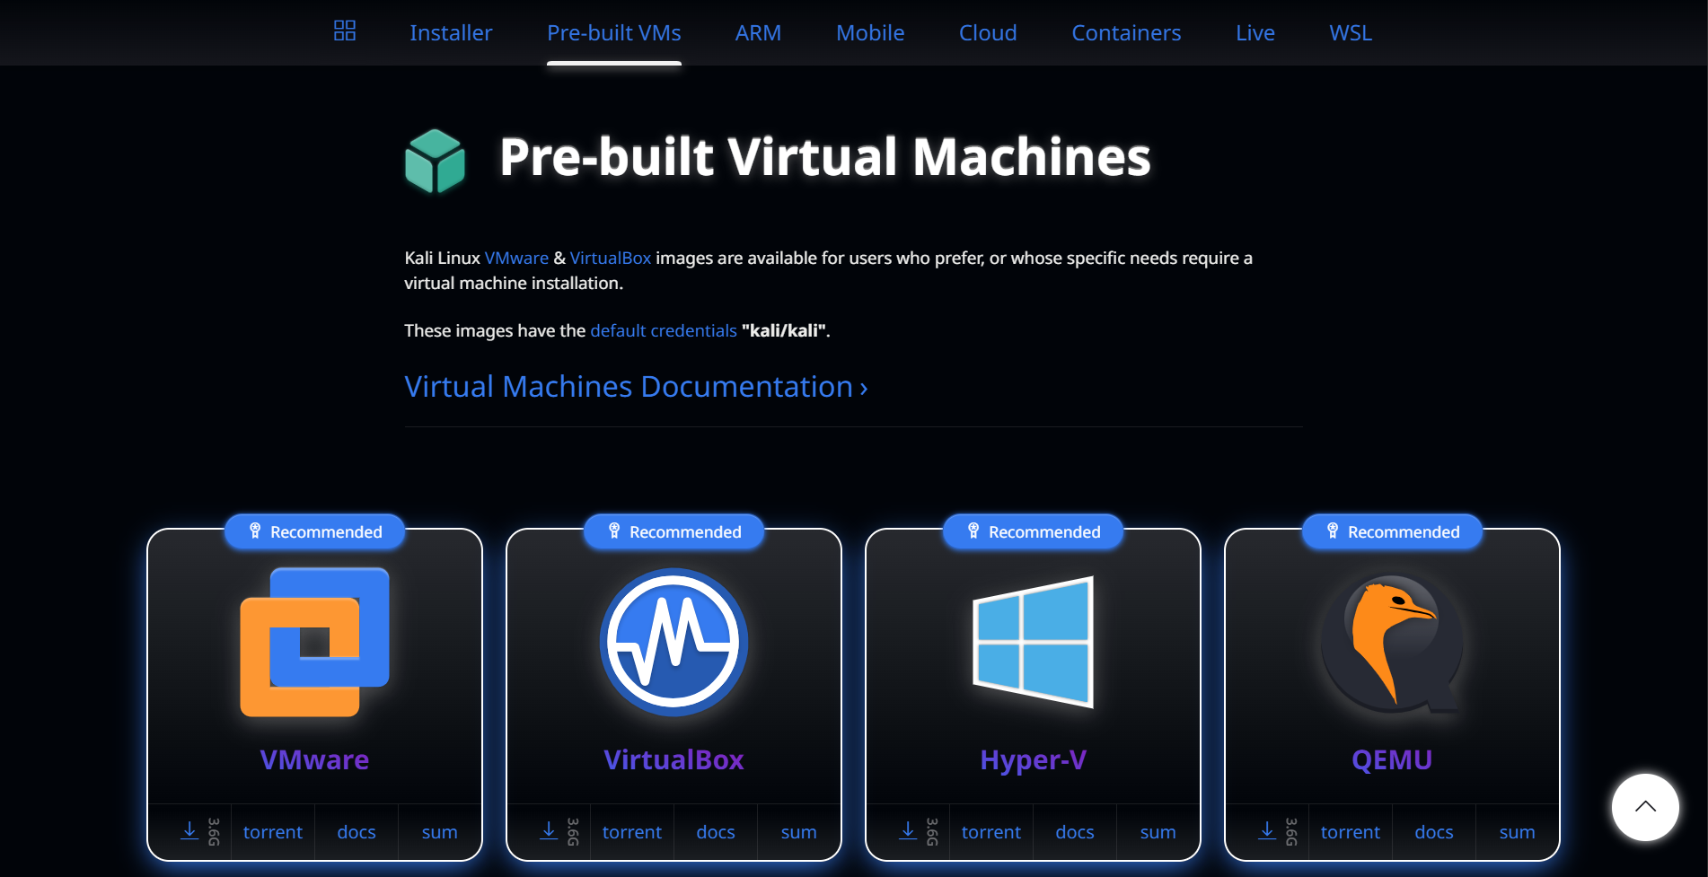
- Extracting all the Kali Linux VM files after downloading it
- Installing Oracle VirtualBox by following the setup steps
- Opening Oracle VirtualBox after the installation is properly complete
- Opening and starting Oracle VirtualBox on the system properly
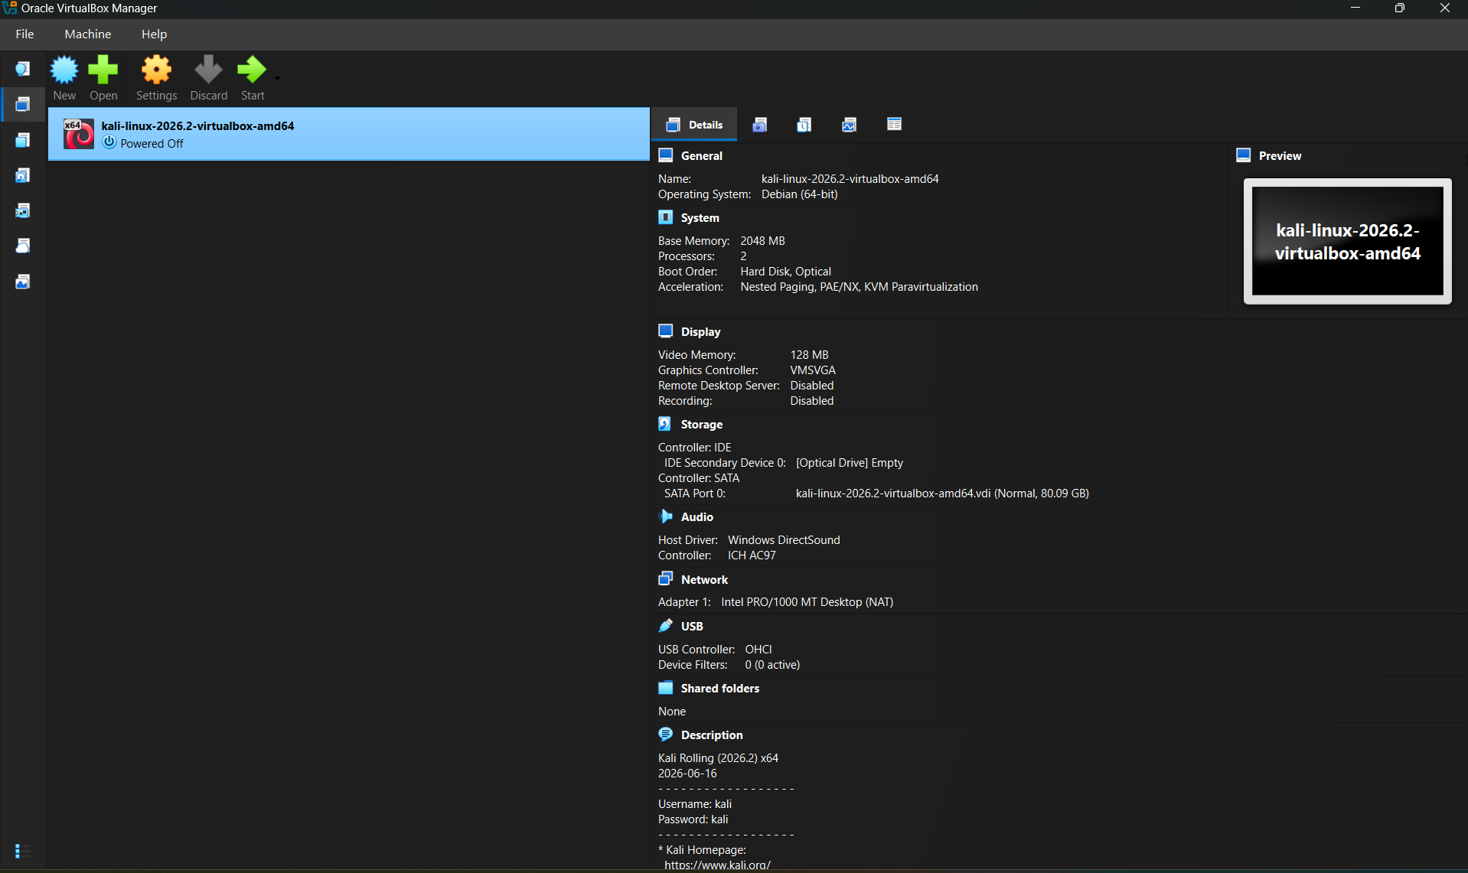
- Opening and starting Kali Linux VM in Oracle VirtualBox properly
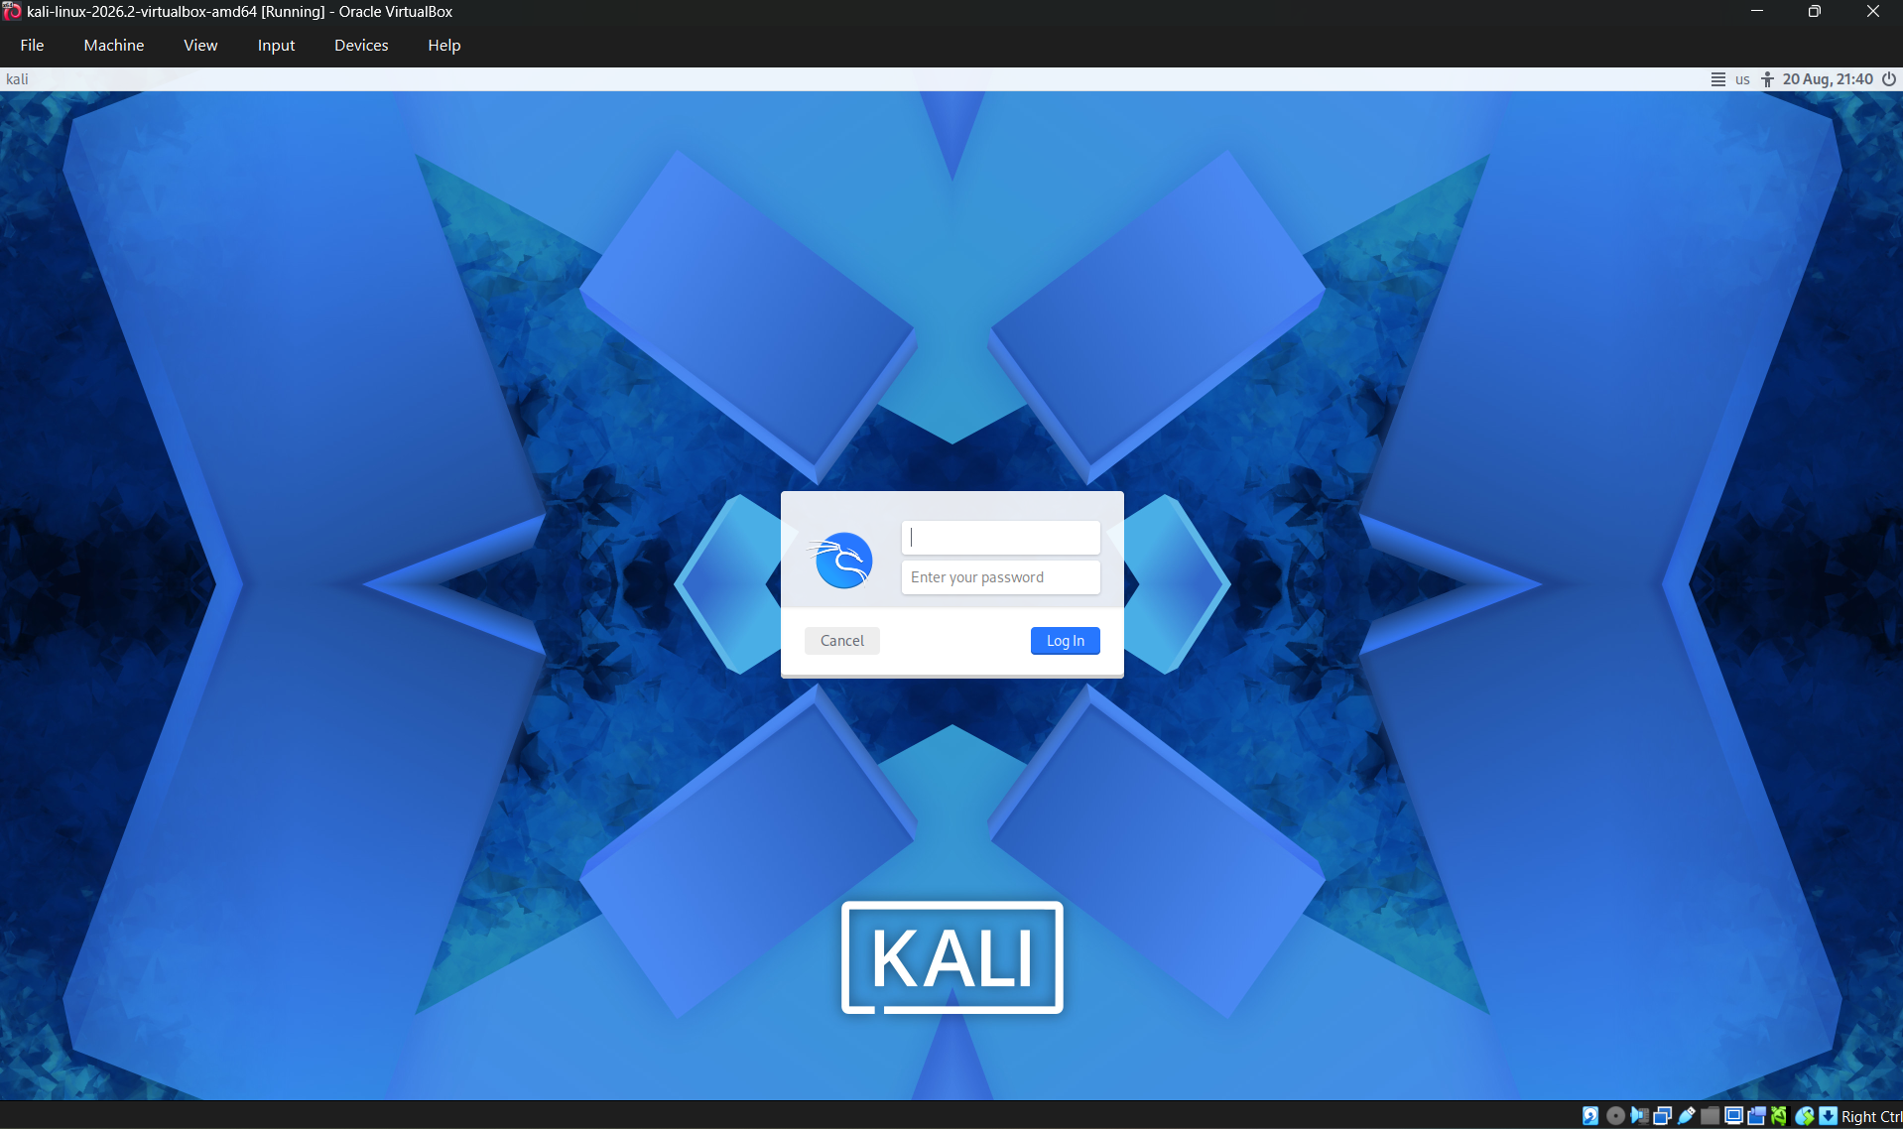
- Getting started on the Kali Linux VM

Basic Linux Commands: -
- ‘pwd’ = Shows the current location of the current location where the user is currently working in
- ‘mkdir’ = Creates a new directory (folder)
- ‘rmdir’ = Removes an empty directory (folder) permanently
- ‘ls’ = Displays the current location of all files, folders and directories
- ‘cd’ = Moves the items into some another desired folder
- ‘cd’ = Goes one folder bac, which was used previously
- ‘clear’ = Clears the command terminal window entirely
- ‘history’ = Shows all the commands used earlier by the user
- ‘man’ = Shows help/manual for a particular command
- ‘whoami’ = Discloses the identity of the current user of the system.

File Handling Commands: -
- ‘vi’ = Opening a file for creating or editing purposes
- ‘file’ = Shows the type of the particular chosen file
- ‘rm’ = ‘Removal of the particular chosen file
- ‘cp’ = Makes a copy of the particular chosen file
- ‘mv’ = Moves a particular chosen file to a particular chosen location or changes name of the folder
- ‘cat’ = Reveals all the contents of a particular chosen file
- ‘more’ = Displays all the contents of a particular chosen file, one single page at a time
- ‘less’ = Lets the user easily scroll through the displayed contents of the particular chosen file
- ‘head’ = Displays the opening lines of the particular chosen file

To save a file in ‘vi’, press ‘Esc’, type ‘:wq’ and then press ‘Enter’. This saves the particular chosen file and completely closes the editor.

Final Conclusion: - Oracle VirtualBox and Kali Linux VM were set up successfully in the system. Basic Linux directory and file commands in the terminal were also demonstrated. After this experiment, the Linux environment installed in the system was finally ready to use for writing, compiling and running programmes in C software programming language.

